Ideation Phase

Define the Problem Statements

Date | 9 February 2026
Team ID | LTVIP2026TMIDS82439
Project Name | LearnHub — Online Learning Platform (OLP)
Maximum Marks | 2 Marks

Customer Problem Statement Template:
Create a problem statement to understand your customer's point of view. The Customer Problem Statement template helps you focus on what matters to create experiences people will love.
A well-articulated customer problem statement allows you and your team to find the ideal solution for the challenges your customers face. Throughout the process, you’ll also be able to empathize with your customers, which helps you better understand how they perceive your product or service.
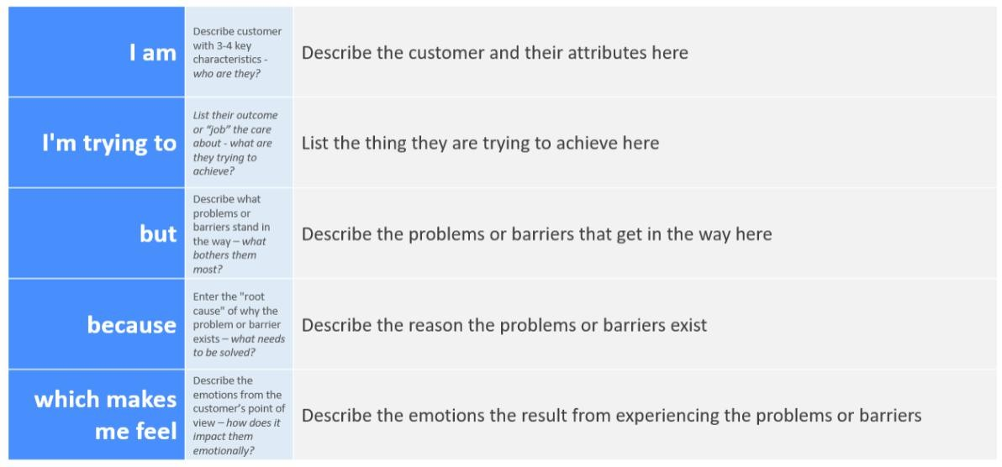
Reference: https://miro.com/templates/customer-problem-statement/
Example:
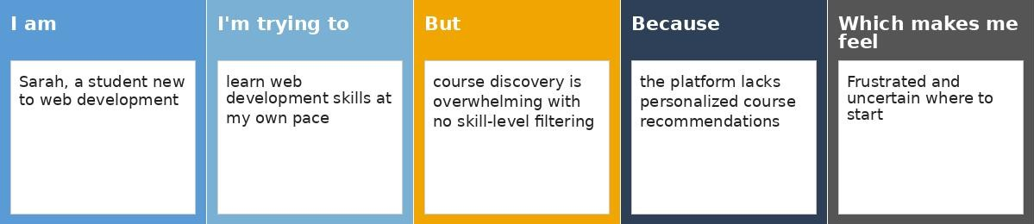

Problem  Statement (PS) | I am  (Customer) | I’m trying to | But | Because | Which makes me feel
PS-1 | Sarah, a | learn web | course | the platform | frustrated and uncertain
 | student new | development | discovery | lacks | about where to start my
 | to web | skills at my | is | personalized | learning journey
 | development | own pace | overwhel | course
 |  |  | ming with | recommendat
 |  |  | no clear | ions for
 |  |  | skill-level | beginners
 |  |  | filtering
PS-2 | John, an | create and | the course | there is no | demotivated and
 | experienced | manage high- | creation | real-time | disconnected from my
 | web | quality | tools lack | dashboard to | learners
 | developer | courses on the | analytics | monitor
 | and | platform | and | enrollments
 | instructor |  | student | or student
 |  |  | engageme | progress
 |  |  | nt metrics

